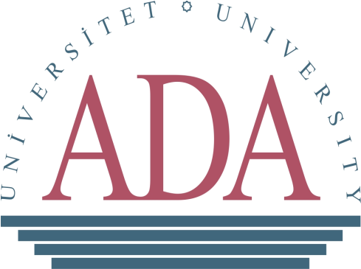

ADA University

Office of International Affairs

Address: ADA University 11 Ahmadbay Agha-Oglu Street Baku, Azerbaijan, AZ1008
Tel: (+994 12) 437 32 35 ext: 290 Fax: (+994 12) 437 32 36
exchange@ada.edu.az

Application Form for Exchange Programs

Application Deadline:

(For Fall Semester, September through December 2018, for academic year 2018-2019: April 30, 2018)

(For Spring Semester, January through May 2019: October 30, 2018)

Note: Partner institutions should set an earlier deadline for an internal nomination.

Name of Applicant: ………………………………………………….

Home Institution: ……………………………………………………

1. Personal information
Photo

Last Name: First Name:

Middle Name: Birth Country:

Nationality: Date of Birth:

Sex: ☐ Male ☐ Female

Present Address:
Tel: |  |  |  | E-mail:

Person to be notified in case of emergency
Name : |  | Tel:
Address: |  | E-mail:

2. Home Institution

Name of University:

Faculty / School:

Department:

Major Field of Study:

Cumulative GPA:

Entrance (Month/ Year): Level: ☐ Master ☐ Bachelor

School Year: Expected graduation time (Month/ Year):

3. Educational Background

Academic Year | University / School | Level attained,  Degrees awarded

4. Work and Extracurricular Experience

5. Language Self Evaluation (Check the appropriate box)

 | Native Lagunage | Excellent | Good | Fair | Poor
English | ☐ | ☐ | ☐ | ☐ | ☐
Azerbaijani | ☐ | ☐ | ☐ | ☐ | ☐
(Others: Specify) | ☐ | ☐ | ☐ | ☐ | ☐
(Others: Specify) | ☐ | ☐ | ☐ | ☐ | ☐

6. Desired Study Period at ADA University (Select one of the options below)

☐ Fall Semester
☐ Spring Semester
☐ Fall and Spring Semester (1 academic year)

7. Reason(s) for applying to ADA University Exchange Program

Attach a separate sheet, if necessary.
8. Study Plan (for graduate students only)
(Describe your study plan during your stay at ADA University.)

Attach a separate sheet, if necessary.

